DASH Azure VM Access Guide

Input Guide
This section outlines the input parameters required for provisioning Azure Virtual Machines using the DASH Portal. Each parameter includes a description, available options, usage guidance, and notes on valid combinations when applicable.
Input Parameter | Description | Values Provided | Value Guidance | Valid Combinations
Service_name | The name of the service to install on the VM | docker, kubernetes, llavallm, minio, nfs, nginx, postgres, mongodb, none | Choose based on the role the VM will serve (e.g., Docker for container hosts, Postgres for DB) | N/A
region | Azure region where the VM will be deployed | East US, Central US, West US 2, Central India, UK South, Canada Central, East Asia, South Central US | Select the region closest to end users or related services for latency optimization | N/A
os_template | The base image template used for the VM OS | ubuntu1804, ubuntu2004, ubuntu2204, ubuntu2404, windows2019dc, windows2019dc-gensecond, windows2022dc, rhel-7-lvm, rhel-8-lvm-gen2, | Choose an OS based on your workload | N/A
size | Azure VM SKU/size to allocate | e.g.,  Standard_DS1_v2,  Standard_DS2_v3, Standard_D2as_v4,Standard_B2s | Choose based on workload requirements (CPU, RAM, disk throughput) | N/A
environment | The DASH environment where the resource will reside | dev, prod | Use dev for testing/staging and prod for live workloads | N/A
name | A unique name to identify the VM | Any alphanumeric string with dashes | Use clear naming conventions for easier resource management | N/A
owner | The team or individual responsible for provisioning, managing, and maintaining the resource. | Specify the team name or individual responsible for maintaining the VM. | Provide correct team/individual name. | N/A
application | Associated service or application name for the resource. | Enter the associated service name linked to the VM. | Provide a service name linked to the VM. | N/A
project | Project or initiative name linked to the resource. | Indicate the project or initiative name related to the resource. | Provide the project name related to the resource. | N/A
deployment | The target environment (e.g., development, testing, prod) where the resource will be provisioned. | Define the deployment environment name (e.g., dev, test, prod) | Choose the environment where the VM has to be deployed. | N/A
user_script_commands | Commands to attach to a VM at the time of provisioning. | Enter command lets you skip manual setup after VM creation. | Enter the commands to run on the VM during provisioning. | N/A
Services expire after 30 days. Create this service now, or schedule for a later date? | VM will be deleted 30 days after creation, or it can be scheduled to be created at a later date. | Create Now (or)  Schedule for Later | Choose based on VM requirements. | N/A

Sample Input Selection:
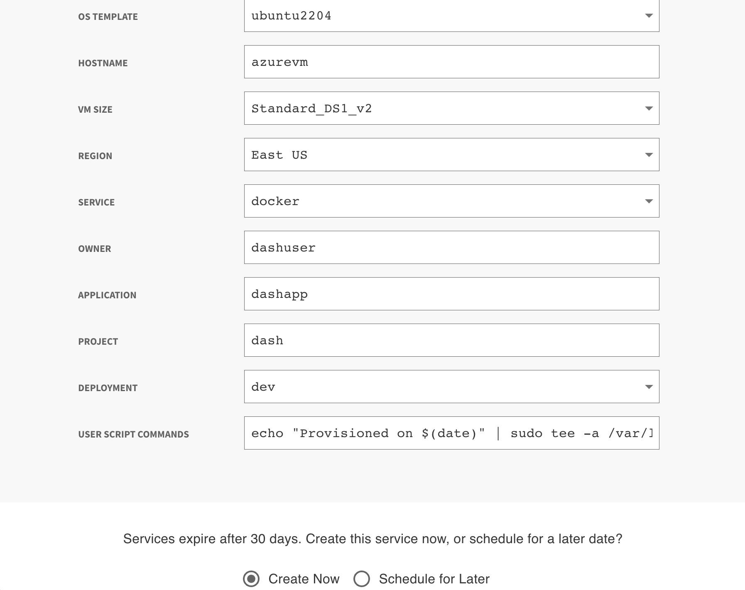

Output Guide
This section outlines the output values generated after Azure Virtual Machine provisioning through the DASH Portal. These outputs can be used to access, manage, and connect to your virtual machine.
Outputs | Description | Example Value
vm_name | Name of the virtual machine on the cloud system | dash-check-nIZ5
computer_name | Name of the host | dash-check-nIZ5
ssh_username | Username for the server to log in. | dash
ssh_password | Password to SSH into the host | 0l<alU64W
private_ip_address | Private IP Address of the VM | 10.0.0.4
public_ip_address | Public IP Address of the VM | 40.87.62.174

What You Can Do with These Outputs
Use the following commands to connect to and manage your Azure Virtual Machine. Replace placeholder values like <public_ip_address>, <ssh_username>, etc., with the actual outputs provided during provisioning.
1. SSH into the Virtual Machine (Linux-based OS)
Command:
ssh <ssh_username>@<public_ip_address>

Example:
ssh azureuser@20.50.12.101

2. RDP into the Virtual Machine (Windows-based OS)
1. Open Remote Desktop Connection (mstsc on Windows).
2. Enter the Public IP Address (e.g., 20.50.12.101).
3. Use the username (ssh_username) and password (ssh_password) from the outputs.

